Reference: https://www.youtube.com/watch?v=3m29S2rbqBw&feature=youtu.be

Remotely connect the raspberry pi
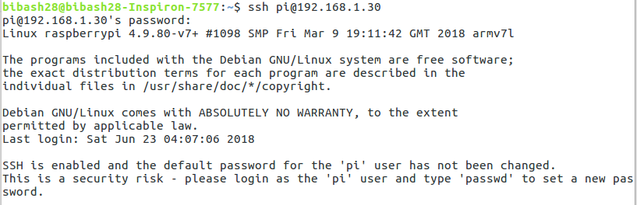
Connect the web camera to the pi and check the connection
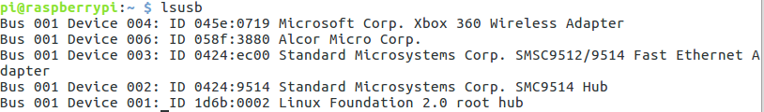
I have connected Xbox joystick and web camera(Alcor Micro Corp)

Start the installation process
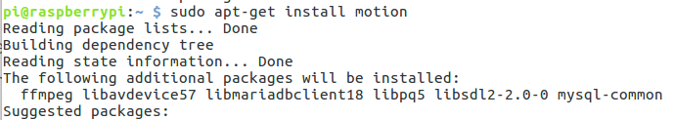
Then change some setting

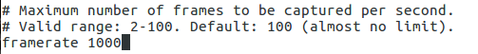

Do not change the stream port
Set stra,_quality to 100
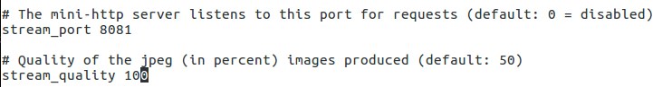

Set stream_local host to OFF
Set webcontrol_localhost to off

Set quality = 100
Set Width = 640 and Height = 480
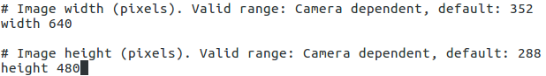
Set post_capture to 5
Save the setting

Set start_motion_daemon to yes
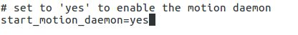

Start the server

